HOW TO START THE GAME?

What we should do:
  - Move the centre pawns
We can start the game with 1. e4, 1.d4, 1.c4 or 1.Nf3. Among those moves, e4 and d4 are the most common.
For Black, to encounter 1.e4 we have 1… e5, 1… e6 (French Defense), 1…d5 (Scandinavian Defense), 1…d6 (Ufimsev Defense), 1…c5 (Sicilian Defense), 1…c6 (Caro-Kann Defense), 1…Nf6 (Alekhine Defense) and so on.
  - Develop the minor pieces (especially Kingside first)
Knights often develop before Bishops; we should develop Kingside first so that we can do castling early.
  - Early Castling
Early castling helps shelter the King and quickly brings the Rook into play.
  - Develop the rest of your forces till the Rooks are linked up
This development ensures that all your forces are ready for battle.
Example some basic opening plays:

- Italian game: 1. e4 e5 2. Nf3 Nc6 3.Bc4 Bc5 4. c3 Nf6 5. d3 d6 6. 0-0 0-0

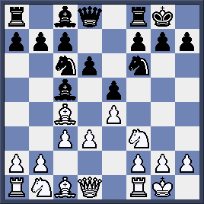
The positon arises after both sides have castled.

- Spanish Game (Ruy Lopez): 1. e4 e5 2. Nf3 Nc6 3. Bb5 a6 4. Ba4 Nf6 5.0-0 Be7 6. Re1 b5 7. Bb3 d6 8. c3 0-0 9.h3 Bb7 10.d4 Re8 11.Nbd2 h6
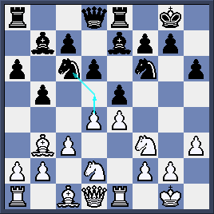

The position arises after 11…h6: both sides are struggling for the centre.

What we should not do:
  - Making too many pawn moves
It could affect the development of your forces.
  - Repeating moves by the same piece unnecessarily
It would cost you tempo (time in the game), affecting the development.
  - Delaying castling.
Your King would come under fatal attack if it remains too long at the centre.
  - Opening up files or diagonals related to King.
Avoid moving the f-pawn in the opening as it opens up diagonals related to King.

